**25**

**Capacitance and Dielectrics**

|  |
| --- |
| **CHAPTER OUTLINE** |

25.1 Definition of Capacitance

25.2 Calculating Capacitance

25.3 Combinations of Capacitors

25.4 Energy Stored in a Charged Capacitor

25.5 Capacitors with Dielectrics

25.6 Electric Dipole in an Electric Field

25.7 An Atomic Description of Dielectrics

* An asterisk indicates a question or problem new to this edition.

|  |
| --- |
| **SOLUTIONS TO THINK-PAIR-SHARE AND ACTIVITIES** |

**\*TP25.1 Conceptualize** The force on the upper plate of the capacitor due to the lower plate depends on the separation distance. Therefore, there will a critical separation distance that provides just the force necessary to balance the weight of the ball on the left.

**Categorize** The hanging ball (as well us the upper plate of the capacitor) is modeled as a *particle in equilibrium.*

**Analyze** (a) The string will transmit the downward force on the upper capacitor plate to the ball, where the force from the string will be upward. Write a force equilibrium equation for the ball from the particle in equilibrium model:

 (1)

Because the upper plate of the capacitor is also a particle in equilibrium, the tension in the string is the same as the magnitude of the downward force on the top plate of the capacitor. Imagine that the bottom plate of the capacitor (imagined to be infinitely large compared to the separation distance between the plates) sets up an electric field as we found in Example 23.8:

 (2)

where ** is the charge density on the bottom plate. If the charge on the bottom plate is *Q* and its area is *A*, substitute for the charge density in Equation (2):

 (3)

Now imagine that the upper plate of charge *Q* is placed in the electric field due to the bottom plate, and use Equation 22.8 to find the force on the upper plate:

 (4)

This force is the same as the tension in the string, so substitute Equation (4) into Equation (1):

 (5)

Use Equation 25.1 to express the charge *Q* on the capacitor in Equation (5) in terms of the capacitance and the voltage:

 (6)

Use Equation 25.3 to express the capacitance in terms of the physical parameters:

 (7)

(b) Now imagine that the separation is the value of *d* we found in part (a) and the system is in equilibrium. What happens if we disturb the ball or the upper plate by moving them up or down a very small distance? Will the system return to equilibrium, like a stretched spring, or will the plates clap together or fly apart? The left side of the first part of Equation (7) is the force on the upper plate. Let’s simplify the expression:

 (8)

Notice that this expression is *not* of the form of Hooke’s law; there is no negative sign to represent a restoring force, and the force is not proportional to the separation distance *d*. This suggests that the system might not be stable. Let’s check. Suppose the upper plate moves upward a bit. For the system to be in stable equilibrium, the downward force on the upper plate must *increase* to pull the plate back down again. But Equation (8) tells us that an increase in *ddecreases* the downward force on the upper plate. Then, the weight of the ball is larger than the electric force on the upper plate and the plates fly apart. Similarly, if the upper plate is moved downward slightly, the force between the plates increases, and the plates clap together. The system is clearly unstable.

**Finalize** For practice, think about what happens if the battery is removed so that the plates maintain a fixed charge *Q* rather than a fixed potential difference ∆*V*. Are the results the same?

*Answers:* (a)  (b) unstable

**\*TP25.2 Conceptualize** Ideally, your supply would contain many values of capacitance, so you could simply choose the appropriate single capacitor for your need. Your situation is not ideal, however, so you must create particular values of capacitance from your two available values.

**Categorize** This problem involves series and parallel combinations of capacitors.

**Analyze** Notice that both groups in parts (a) and (b) require a total capacitance that is between the available capacitances of 20 **F and 50 **F. It is helpful to evaluate combinations of the available capacitances. A series combination reduces the overall capacitance and a parallel combination increases it. Consider the following combinations:

(1) 20 **F and 20 **F in series: 10 **F

(2) 20 **F and 20 **F in parallel: 40 **F

(3) 50 **F and 50 **F in series: 25 **F

(4) 50 **F and 50 **F in parallel: 100 **F

(a) For 45 **F, we can add 25 **F (combination 3) and 20 **F (available). To add capacitances, the capacitors must be in parallel, so

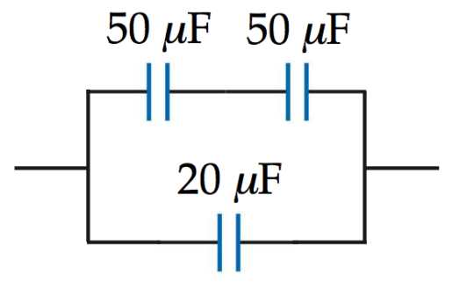

(b) For 35 **F, we can add 25 **F (combination 3) and 10 **F (combination 1). To add capacitances, the capacitors must be in parallel, so

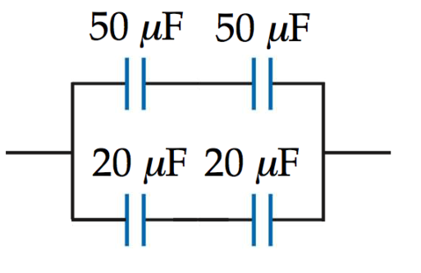

(c) The larger the total capacitance, the more ways there are to add individual capacitances and capacitance combinations. Three examples are shown below:

105 **F = 5 **F + 100 **F

This can be formed with two of combination 1 in series and then combination 4 in parallel:

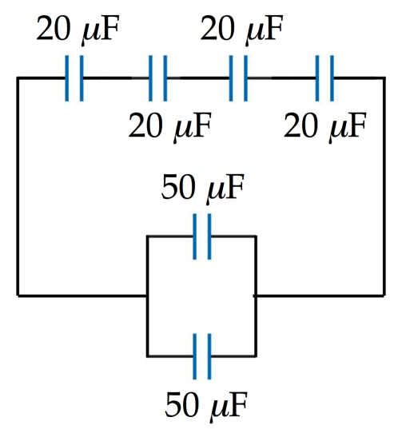

105 **F = 10 **F + 25 **F + 20 **F + 50 **F

This can be formed with a parallel connection of combination 1, combination 3, and one each of the available capacitances:

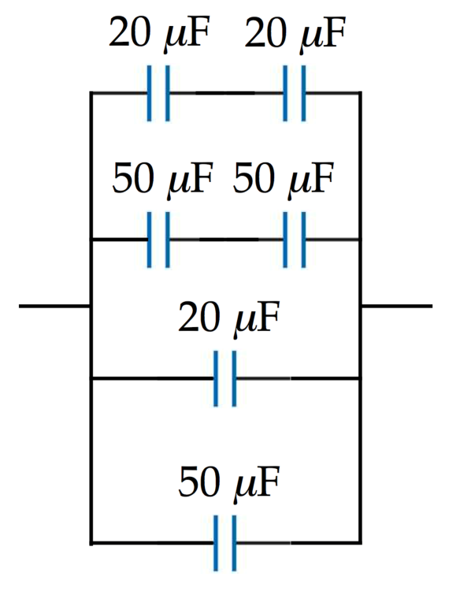

105 **F = 75 **F + 30 **F = 3(25 **F) + 3(10 **F )

This can be formed with a parallel connection of three of combination 3 with three of combination 1:

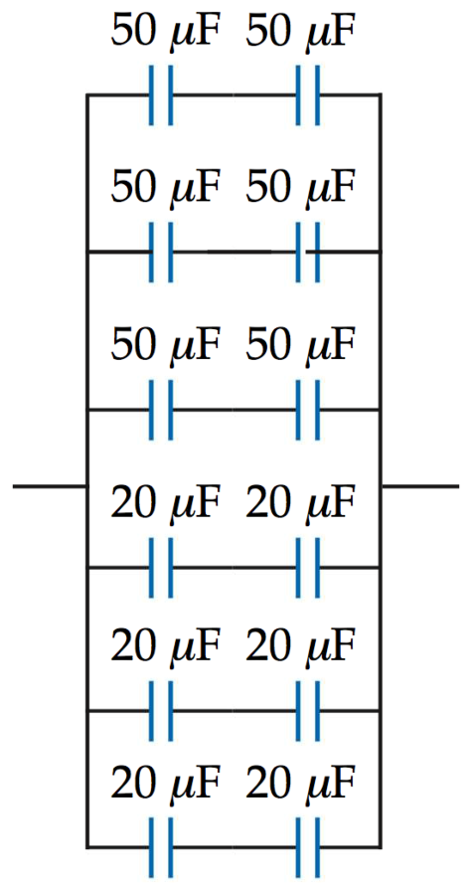

**Finalize** Can all integer values of capacitance be formed from these two available values? For example, beginning with the circuit in part (b), can you devise a combination of the available capacitances to give a total capacitance of 36 **F?

*Answers:* (a) (i)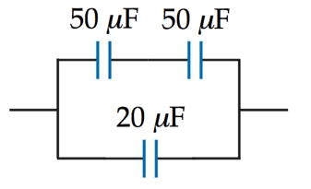 (ii) 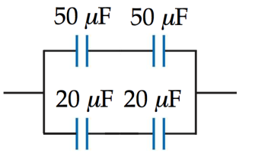

(b) Three possibilities:

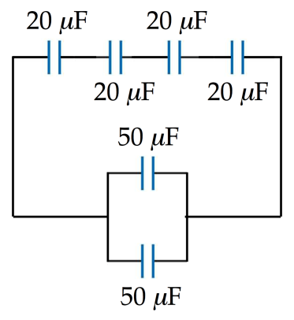

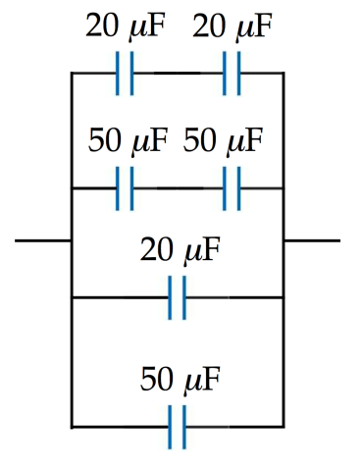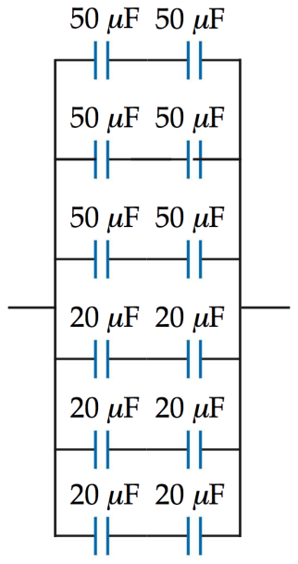

|  |
| --- |
| **SOLUTIONS TO END-OF-CHAPTER PROBLEMS** |

**Section 25.1 Definition of Capacitance**

**P25.1** (a) From Equation 25.1 for the definition of capacitance,  we have



(b) Similarly,



**P25.2** (a) 

(b) 

**Section 25.2 Calculating Capacitance**

**P25.3** We have Thus, 

The surface charge density on each plate has the same magnitude, given by



Thus,





**P25.4** (a) 

(b) 

(c) 

**P25.5** With *θ*= *π*, the plates are out of mesh and the overlap area is zero. With *θ* = 0, the overlap area is that of a semi-circle, . By proportion, the effective area of a single sheet of charge is

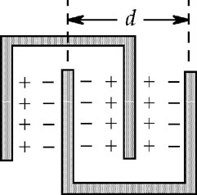

**ANS. FIG. P25.5**



When there are two plates in each comb, the number of adjoining sheets of positive and negative charge is 3, as shown in the sketch. When there are *N* plates on each comb, the number of parallel capacitors is 2*N* − 1 and the total capacitance is



**P25.6 **



Dividing, 

so 

and 

**Section 25.3 Combinations of Capacitors**

**P25.7** (a) When connected in series, the equivalent capacitance is , or



(b) When connected in parallel, the equivalent capacitance is



**P25.8** The capacitance of the combination of extra capacitors must be  The possible combinations are: one capacitor: *C*; two capacitors: 2C or  three capacitors: 3*C*,  or  None of these is  so the desired capacitance cannot be achieved.

**P25.9** Call *C* the capacitance of one capacitor and *n* the number of capacitors. The equivalent capacitance for *n* capacitors in parallel is

*Cp*= *C*1+ *C*2 + . . . + *Cn* = *nC*

The relationship for *n* capacitors in series is



Therefore,



**P25.10** (a) Capacitors 2 and 3 are in parallel and present equivalent capacitance 6*C*. This is in series with capacitor 1, so the battery sees capacitance .

(b) If they were initially uncharged, C1 stores the same charge as C2 and C3 together. With greater capacitance, C3 stores more charge than C2. Then .

(c) The  equivalent capacitor stores the same charge as C1. Since it has greater capacitance,  implies that it has smaller potential difference across it than C1. In parallel with each other, C2 and C3 have equal voltages: .

(d) If C3 is increased, the overall equivalent capacitance increases. More charge moves through the battery and *Q* increases. As ∆V1 increases, ∆V2 must decrease so Q2 decreases. Then Q3 must increase even more: .

**P25.11** (a) We simplify the circuit of Figure P25.11 in three steps as shown in ANS. FIG. P25.11 panels (a), (b), and (c). First, the 15.0-**F and 3.00-**F capacitors in series are equivalent to

= 2.50 **F

Next, the 2.50-**F capacitor combines in parallel with the 6.00-**F capacitor, creating an equivalent capacitance of 8.50 **F. At last, this 8.50-**F equivalent capacitor and the 20.0-**F capacitor are in series, equivalent to

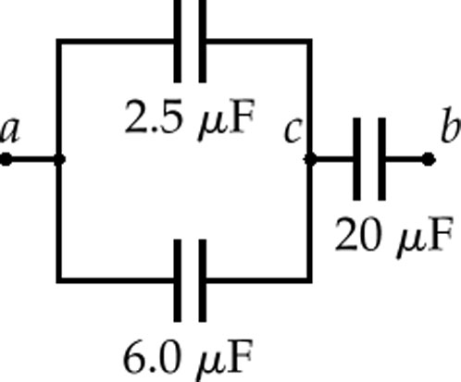

(a)

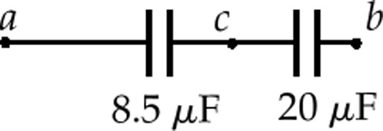

(b)

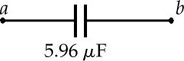

(c)

**ANS. FIG. P25.11**



(b) We find the charge on each capacitor and the voltage across each by working backwards through solution figures (c) − (a), alternately applying and to every capacitor, real or equivalent. For the 5.96-**F capacitor, we have



Thus, if *a* is higher in potential than *b*, just 89.5 **C flows between the wires and the plates to charge the capacitors in each picture. In (b) we have, for the 8.5-**F capacitor,



and for the 20.0-**F capacitor in (b), (a), and the original circuit, we have *Q*20 = 89.5 **C. Then



Next, the circuit in diagram (a) is equivalent to that in (b), so   
= 4.47 V and = 10.5 V.

For the 2.50-**F capacitor, = 10.5 V and



For the 6.00-**F capacitor, ∆*V* = 10.5 V and

*Q*6 =*C*∆*V* = (6.00 **F)(10.5 V) = 

Now, 26.3 **C having flowed in the upper parallel branch in (a), back in the original circuit we have *Q*15 = 26.3 **C and   
*Q*3 = 26.3 **C.

**P25.12** (a) In the upper section, each *C*1-*C*2 pair, on either side of *C*3 , are in series:

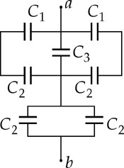

**ANS. FIG. P25.12**



and both *C*1*-C*2 pairs are in parallel to *C*3:



In the lower section, the *C*2*-C*2 pair are in parallel:



The upper section is in series with the lower section:



(b) Capacitors in series carry the same charge as their equivalent capacitor; therefore, the upper section, equivalent to a 8.67-**F capacitor, and the lower section, equivalent to a 20.0-**F capacitor, carry the same charge as a 6.05-**F capacitor:



The upper section is equivalent to capacitor *C*3 and two 3.33-**F capacitors in parallel, and the voltage across each is the same as that across a 8.67-**F capacitor:



Therefore, the charge on *C*3 is



**P25.13** 

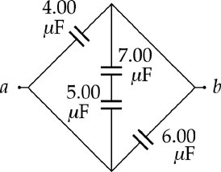

**ANS. FIG. P25.13**

**\*P25.14 Conceptualize** The capacitance of the main capacitor could be above or below the design value. Therefore, we may have to add capacitors in either series, to reduce the capacitance, or parallel, to increase it.

**Categorize** This is a problem that involves series and parallel combinations of capacitors.

**Analyze** The range of capacitors produced is 32.0 **F  5.00%, or



Capacitances from 31.5 **F to 32.5 **F are in the acceptable range and do not need extra capacitors. Therefore, keeping in mind the three-significant-figure measurement capability, the ranges over which we need correction are



Let us imagine first that the main capacitance is too large. We will have to add an extra capacitor in series to attain a smaller equivalent capacitance. Therefore, the extra capacitance to be added in series will be associated with achieving the desired equivalent capacitance, 32.0 **F, for a main capacitance between the limits of 32.6 **F and 33.6 **F. (The higher the main capacitor is above the desired value, the *smaller* must be the extra capacitance to be added in series.) Therefore, for a series combination,

 (1)

Substitute numerical values to find the extra capacitance needed for the limits of the range:





Therefore, the range of extra capacitances required is



Now imagine that the main capacitance of the capacitors produced is in the range that is too small. We will have to add an extra capacitor in parallel to attain a larger equivalent capacitance. The capacitance to be added in parallel will be associated with achieving the desired equivalent capacitance, 32.0 **F, for a main capacitance between the limits of 30.4 **F and 31.4 **F.

Therefore,

 (2)

Substitute numerical values to find the extra capacitance needed in parallel for the limits of the range:





So the parallel combination gives us a requirement of



to give the exact desired equivalent capacitance.

**Finalize** How would the answers change if your team decided that the corrected capacitances did not have to be exactly 32.0 **F? For example, what if the corrected capacitance were allowed to be in the range of 31.8 **F to 32.2 **F

*Answer:* and 

**P25.15** Cp = C1 + C2 and Substitute C2 = Cp− C1:



Simplifying,





We choose arbitrarily the + sign. (This choice can be arbitrary, since with the case of the minus sign, we would get the same two answers with their names interchanged.)

**P25.16** Cp = C1 + C2 and

Substitute

C2 = Cp− C1: 

Simplifying,



and 

where the positive sign was arbitrarily chosen (choosing the negative sign gives the same values for the capacitances, with the names reversed).Then, from C2 = Cp− C1, we obtain

 

**Section 25.4 Energy Stored in a Charged Capacitor**

**P25.17** (a) 

(b) 

**P25.18** (a) The equivalent capacitance of a series combination of *C*1 and *C*2 is



(b) This series combination is connected to a 12.0-V battery, the total stored energy is



(c) Capacitors in series carry the same charge as their equivalent capacitor. The charge stored on each of the two capacitors in the series combination is



and the energy stored in each of the individual capacitors is:

18.0 **F capacitor: 

36.0 **F capacitor:



(d) 

(e) 

(f) If *C*1 and *C*2 were connected in parallel rather than in series, the equivalent capacitance would be *C*eq = *C*1 + *C*2 = 18.0 **F + 36.0 **F = 54.0 **F. If the total energy stored in this parallel combination is to be the same as stored in the original series combination, it is necessary that



From which we obtain



(g) Because the potential difference is the same across the two capacitors when connected in parallel, and 

**P25.19** (a) Because the capacitors are connected in parallel, their voltage remains the same:



(b) Because  and *d* → 2*d*, the altered capacitor has new capacitance to . The total charge is the same as before:



(c) New 



(d) 

**P25.20** Before the capacitors are connected, each has voltage ∆*V* and charge *Q*.

(a) Connecting plates of like sign places the capacitors in parallel, so the voltage on each capacitor remains the same.



(b) Because  the altered capacitor has new capacitance  and this change in capacitance results in a new potential difference  across the parallel capacitors. We can solve for the new potential difference because the total charge remains the same:



(c) Each capacitor has potential difference ∆*V*′:



(d) 

**P25.21** (a) The circuit diagram for capacitors connected in parallel is shown in ANS. FIG. P25.21(a).

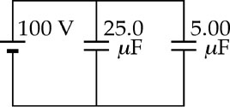

**ANS. FIG. P25.21(a)**

(b) 

an



(c) 



(d) The circuit diagram for capacitors connected in series is shown in ANS. FIG. P25.21(d).

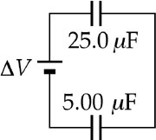

**ANS. FIG. P25.21(d)**

**P25.22** To prove this, we follow the hint, and calculate the work done in separating the plates, which equals the potential energy stored in the charged capacitor:



Now from the fundamental theorem of calculus, *dU*E= *Fdx*

and 

Performing the differentiation,



**P25.23** (a) According to Equation 25.2, we may think of a sphere of radius *R* that holds charge *Q* as having a capacitance . The energy stored is



(b) The total energy is



(c) For a minimum we set 



which gives



(d) 

(e) , and



(f) 

**Section 25.5 Capacitors with Dielectrics**

**P25.24** (a) Consider two sheets of aluminum foil, each 40 cm by 100 cm, with one sheet of plastic between them.

(b) Suppose the plastic has  and thickness   
1 mil .

Then, 

(c) 

**P25.25** (a) 

(b) 

**P25.26** (a) Note that the charge on the plates remains constant at the original value, Q0, as the dielectric is inserted. Thus, the change in the potential difference, is due to a change in capacitance alone. The ratio of the final and initial capacitances is



and 

Thus, the dielectric constant of the inserted material is .

(b) The material is probably  (see Table 25.1).

(c) The presence of a dielectric weakens the field between plates, and the weaker field, for the same charge on the plates, results in a smaller potential difference. If the dielectric only partially filled the space between the plates, the field is weakened only within the dielectric and not in the remaining air-filled space, so the potential difference would not be as small. The voltage would lie somewhere between 25.0 V and 85.0 V.

**P25.27** ANS. FIG. P25.27 exaggerates how the strips can be offset to avoid contact between the two foils. It shows how a second paper strip can be used to roll the capacitor into a convenient cylindrical shape with electrical contacts at the two ends. We suppose that the overlapping width of the two metallic strips is still   
*w*= 7.00 cm. Then for the area of the plates we have inSolving the equation gives

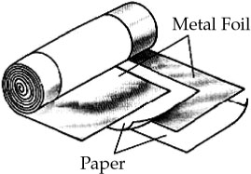

**ANS. FIG. P25.27**



**P25.28** The given combination of capacitors is equivalent to the circuit diagram shown in ANS. FIG. P25.28.

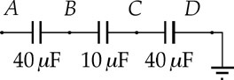

**ANS. FIG. P25.28**

Put charge *Q* on point *A*. Then,



So, , and the center capacitor will break down first, at ∆*V*BC = 15.0 V. When this occurs,



and .

**P25.29** (a) We use the equation *U*E *= Q*2/2*C* to find the potential energy of the capacitor. As we will see, the potential difference changes as the dielectric is withdrawn. The initial and final energies are  and  But the initial capacitance (with the dielectric) is . Therefore, Since the work done by the external force in removing the dielectric equals the change in potential energy, we have



To express this relation in terms of potential difference  we substitute  and evaluate:



The positive result confirms that the final energy of the capacitor is greater than the initial energy. The extra energy comes from the work done *on* the system by the external force that pulled out the dielectric.

(b) The final potential difference across the capacitor is .

Substituting  and  gives



Even though the capacitor is isolated and its charge remains constant, the potential difference across the plates does increase in this case.

**Section 25.6 Electric Dipole in an Electric Field**

**P25.30** (a) The electric field produced by the line of charge has radial symmetry about the *y*axis. According to Equation 23.8 in Example 23.7, the electric field to the right of the *y* axis is

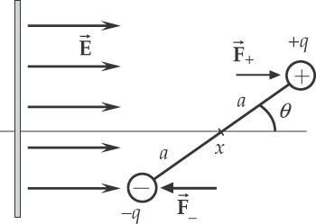

**ANS. FIG. P25.30**



Let *x* = 25.0 cm represent the coordinate of the center of the dipole charge, and let 2*a* = 2.00 cm represent the distance between the charges. Then  is the coordinate of the negative charge and  is the coordinate of the positive charge.

The force on the positive charge is



and the force on the negative charge is



The force on the dipole is



Substituting numerical values and suppressing units,



**P25.31** Let *x* represent the coordinate of the negative charge. Then  is the coordinate of the positive charge. The force on the negative charge is . The force on the positive charge is



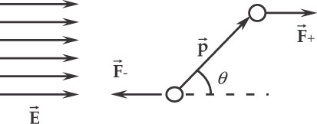

**ANS. FIG. P25.31**

The force on the dipole is altogether



**Section 25.7 An Atomic Description of Dielectrics**

**P25.32** (a) Consider a gaussian surface in the form of a cylindrical pillbox with ends of area  parallel to the sheet. The side wall of the cylinder passes no flux of electric field since this surface is everywhere parallel to the field. Gauss’s law becomes  so  directed away from the positive sheet.

(b) In the space between the sheets, each creates field  away from the positive and toward the negative sheet. Together, they create a field of



(c) Assume that the field is in the positive *x-*direction. Then, the potential of the positive plate relative to the negative plate is



(d) Capacitance is defined by: 

**Additional Problems**

**\*P25.33 Conceptualize** A human body is a single conductor, like the sphere whose capacitance is given by Equation 25.2. As in the discussion related to that equation, we can imagine a capacitor formed from the human body and an imaginary sphere of infinite radius surrounding the human.

**Categorize** Once we estimate the capacitance of the human body, the rest of the problem becomes a substitution problem.

(a) We have *no* information that will allow us to find the capacitance of a human-shaped object. But your supervisor has only asked for an estimate, not an exact value for the parameters requested. Therefore, let us use Equation 25.2 to estimate the capacitance of a human as the capacitance of a human-sized sphere of radius *a*:



where we have used 1.00 m as a typical “radius” for a human. Based on this result, let’s estimate the capacitance of a human to be on the order of



(b) Now use the first form of Equation 25.13 to find the charge on the body at the electric potential energy provided:



(c) Use the last form of Equation 25.13 to find the electric potential of the body:



*Answers:* (a) 100 pF (b) 0.22 **C (c) 2.2 kV

**P25.34** (a) Each face of P2 carries charge, so the three-plate system is equivalent to what is shown in ANS. FIG. P25.34 below.

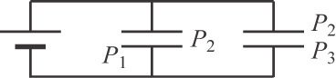

**ans. Fig. P25.34**

Each capacitor by itself has capacitance



Then equivalent capacitance 

(b) 

(c) Now  has charge on two surfaces and in effect three capacitors are in parallel:



(d) Only one face of  carries charge:



**P25.35** From Equation 25.15,



Solving for the volume gives



**P25.36** Imagine the center plate is split along its midplane and pulled apart. We have two capacitors in parallel, supporting the same ∆*V* andcarrying total charge *Q*. The upper capacitor has capacitance and the lower  Charge flows from ground onto each of the outside plates so that

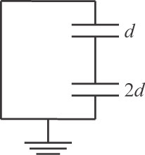

**ans. Fig. P25.36**

and

Then 

(a) 



(b) 

**P25.37** (a) With the liquid filling the space between the plates to height *fd*, the top of the fluid at the air-fluid interface develops an induced dipole layer of charge so that it acts as a thin plate with opposite charge on its upper and lower sides; thus, the partially filled capacitor behaves as two capacitors in series connected at the interface. The upper and lower capacitors have separate capacitances:



The equivalent series capacitance is



(b) For *f* = 0, the capacitor is empty so we can expect capacitance . For *f* = 0,



and .

(c) For *f* = 1, we expect . For *f* = 1,



and .

**P25.38** We can use the energy *U*C stored in the capacitor to find the potential difference across the plates:



When the particle moves between the plates, the change in potential energy of the charge-field system is



where we have noted that the potential difference is negative from the positive plate to the negative plate. Apply the isolated system (energy) model to the charge-field system:



Substitute numerical values:



This decrease in kinetic energy of the particle is more than the energy with which it began. Therefore, the particle does not arrive at the negative plate but rather turns around and moves back to the positive plate.

**P25.39** Where the metal block and the plates overlap, the electric field between the plates is zero. The plates do not lose charge in the overlapping region, but opposite charge induced on the surfaces   
of the inserted portion of the block cancels the field from charge   
on the plates. The unfilled portion of the capacitor has capacitance



The effective charge on this portion (the charge producing the remaining electric field between the plates) is proportional to the unblocked area:



(a) The stored energy is



(b) 

 (into the capacitor: the block is pulled in)

(c) Stress 

(d) The energy density is



(e) 

**P25.40** (a) Put charge *Q* on the sphere of radius *a* and−*Q* on the other sphere. Relative to *V* = 0 at infinity, because *d* is larger compared to *a* and to *b*.

The potential at the surface of *a* is approximately 

and the potential of *b* is approximately .

The difference in potential is 

and 

(b) As ,  becomes negligible compared to and. Then,



as for two spheres in series.

**P25.41** From Gauss's Law, for the electric field inside the cylinder, .

so 



Recognizing that  we obtain



**ANS. FIG. P25.41**



**P25.42** (a)  for a capacitor with air or vacuum beteen its plates. When the dielectric is inserted at constant voltage,



The original energy is



and the final energy is



therefore,



(b) The electric field between the plates polarizes molecules within the dielectric; therefore the field does work on charge within the molecules to create electric dipoles. The extra energy comes from (part of the) electrical work done by the battery in separating that charge.

(c) The charge on the plates increases because the voltage remains the same:



and 

so the charge increases according to .

**P25.43** Placing two identical capacitor is series will split the voltage evenly between them, giving each a voltage of 45 V, but the total capacitance will be half of what is needed. To double the capacitance, another pair of series capacitors must be placed in parallel with the first pair, as shown in ANS. FIG. P25.43A. The equivalent capacitance is



Another possibility shown in ANS. FIG. P25.43B: two capacitors in parallel, connected in series to another pair of capacitors in parallel; the voltage across each parallel section is then 45 V. The equivalent capacitance is



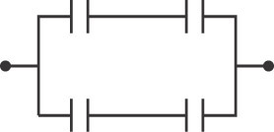

**ans. Fig. P25.43A**

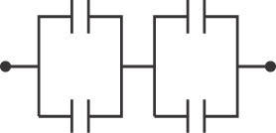

**ans. Fig. P25.43B**

(a) 

(b) 

**P25.44** The condition that we are testing is that the capacitance increases by less than 10%, or,



Substituting the expressions for *C* and C′ from Example 26.1, we have



This becomes



We can rewrite this as



where we have reversed the direction of the inequality because we multiplied the whole expression by −1 to remove the negative signs. Comparing the arguments of the logarithms on both sides of the inequality, we see that



Thus, if *b*> 2.85*a*, the increase in capacitance is less than 10% and it is more effective to increase .

**\*P25.45 Conceptualize** Imagine the switch closing in the figure. With the voltage applied, the plates exert attractive forces on each other and move closer together. This action stretches the springs, increasing the outward force on the plates. At some point the plates reach an equilibrium situation with the forces balanced between the attractive electric force and the spring forces.

**Categorize** Each plate is modeled as a *particle in equilibrium*.

**Analyze** Because you are holding a plate in each hand and allowing the plates to arrive at a new equilibrium position slowly, each plate can be modeled as a particle in equilibrium at all times. For the left-hand plate in Figure P25.45, the force equilibrium equation can be written as

 (1)

where the applied force *F*app from your hand is to the left to keep the plate from accelerating to the right in response to the attraction between the plates. Solve for the applied force and substitute for the spring and electric forces for an arbitrary value of *x* through which the plate moves from its equilibrium position:

 (2)

where*q* is the charge on the left plate and *E* is the magnitude of the electric field set up by the right plate for an arbitrary value of *x*. Use Equation 23.9 for the electric field of a single sheet of charge in Equation (2):

 (3)

The plates remain connected to the battery, so the potential difference between them remains fixed. Use Equation 25.1 to replace the charge *q* in Equation (3):

 (4)

where is the capacitance of the plates for an arbitrary value of *x*, leading to a plate separation of . Use Equation 25.3 to express the capacitance in geometric terms:

 (5)

Replace the numerator in Equation (5) in terms of the original capacitance *C*:

 (6)

When , the plates are in equilibrium between the spring and electric forces, the springs have each stretched by a distance *xf*, and the applied force necessary to keep the plates from accelerating drops to zero:

 (7)

The distance *xf* that each spring stretches is

 (8)

Substitute Equation (8) into Equation (7):



**Finalize** This is the expression requested. For example, if ∆*V* = 100 V, *d* = 8.00 mm, *C* = 2.00 **F, and *f* = 0.500, then *k* = 2 500 N/m. Notice that the procedure is very sensitive to a proper measurement of *d*. If we replace *C* with its equivalent in Equation 25.3, we have



and we see that *k* is inversely proportional to the *cube* of the plate separation distance *d*.

*Answer:*

Challenge Problems

**P25.46** Let charge *λ* per length be on one wire and −*λ* be on the other. The electric field due to the charge on the positive wire is perpendicular to the wire, radial, and of magnitude



The potential difference between the surfaces of the wires due to the presence of this charge is



The presence of the linear charge density −*λ* on the negative wire makes an identical contribution to the potential difference between the wires. Therefore, the total potential difference is



With *D* much larger than *r* we have nearly 

and the capacitance of this system of two wires, each of length , is



The capacitance per unit length is 

**P25.47** According to the suggestion, the combination of capacitors shown is equivalent to 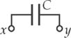

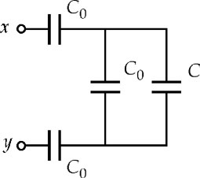

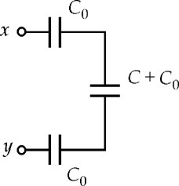

**ANS. FIG. P25.47**

Then, from ANS. FIG. P25.47,





Only the positive root is physical:



**P25.48** (a) Consider a strip of width *dx* and length *W* at position *x* from the front left corner. The capacitance of the lower portion of this strip is The capacitance of the upper portion is  The series combination of the two elements has capacitance



The whole capacitance is a combination of elements in parallel: 

(b) The capacitor physically has the same capacitance if it is turned upside down, so the answer should be the same with *κ*1 and *κ*2 interchanged. We have proven that it has this property in the solution to part (a).

(c) Let *κ*1 = *κ*2 (1 + *x*). Then

As *x* approaches zero we have  as was to be shown.

**P25.49** (a) The portion of the device containing the dielectric has plate area  and capacitance The unfilled part has area  and capacitance  The total capacitance is 

(b) The stored energy is 

(c)  When *x* = 0, the original value of the force is As the dielectric slides in, the charges on the plates redistribute themselves. The force decreases to its final value, when  of

(d) At , 

For the constant charge on the capacitor and the initial voltage we have the relationship



Then the force is 



\***P25.50 Conceptualize** Imagine the switch closing in the figure. With the voltage applied, the plates exert attractive forces on each other and move closer together. This action stretches the springs, increasing the outward force on the plates. At some point the plates reach an equilibrium situation with the forces balanced between the attractive electric force and the spring forces.

**Categorize** Each plate is modeled as a *particle in equilibrium*.

**Analyze** This problem differs from Problem 25.45 due to the introduction of the dielectric between the plates. The problem identifies *C* as the capacitance before the dielectric is inserted and the switch is thrown closed. So, from Equation 25.3,

 (1)

Now imagine that the dielectric is inserted before the switch is thrown. Let us use the results of Example 25.8. The capacitor can now be considered a series combination of two capacitors, one with plate separation *t*, filled with a dielectric, and one with a plate separation *d* −*t*, filled with air. Incorporating Equations 25.3 and 25.16, we can find the equivalent capacitance *C’*:



Express this result in terms of the original *C* by using Equation (1):

 (3)

Now imagine that the switch is thrown. The plate separation begins to decrease. Let us use the results of Example 25.8 again for the situation in which the plates have moved by an arbitrary distance *x* and the plate separation is . The capacitor can now be considered a series combination of two capacitors, one with plate separation *t*, filled with a dielectric, and one with a plate separation , filled with air. Incorporating Equations 25.3 and 25.16, we can find the equivalent capacitance *C’*’:



Express this result in terms of the original *C* by using Equation (1):

 (5)

Because you are holding a plate in each hand and allowing the plates to arrive at a new equilibrium position slowly, each plate can be modeled as a particle in equilibrium at all times. For the left-hand plate in Figure P25.50, the force equilibrium equation can be written as

 (6)

where the applied force *F*app from your hand is to the left to keep the plate from accelerating to the right in response to the attraction between the plates. Solve for the applied force and substitute for the spring and electric forces for an arbitrary value of *x* through which the plate moves from its equilibrium position:

 (7)

where*q* is the charge on the left plate and *E* is the magnitude of the electric field set up by the right plate for an arbitrary value of *x*. Use Equation 23.9 for the electric field of a single sheet of charge in Equation (7):

 (8)

The plates remain connected to the battery, so the potential difference between them remains fixed. Use Equation 25.1 to replace the charge *q* in Equation (8):

 (9)

where is the capacitance of the plates for an arbitrary value of *x*, leading to a plate separation of . Use Equation (5) to substitute for the capacitance:



When , the plates are in equilibrium between the spring and electric forces, the springs have each stretched by a distance *xf*, and the applied force necessary to keep the plates from accelerating drops to zero:



The distance *xf* that each spring stretches is

 (12)

Substitute Equation (12) into Equation (11):



**Finalize**  This is the expression requested. Test this result in the limit **→ 1 and *d*→ 0 to see if it reduces to the result for problem 25.45.

*Answer:*

|  |
| --- |
| **ANSWERS TO QUICK-QUIZZES** |

**1.** (d)

**2.** (a)

**3.** (a)

**4.** (b)

**5.** (a)

|  |
| --- |
| **ANSWERS TO EVEN-NUMBERED PROBLEMS** |

**P25.2** (a) 1.00 **F; (b) 100 V

**P25.4** (a) 1.36 pF; (b) 16.3 pC; (c) 8.00  103 V/m

**P25.6** 

**P25.8** None of the possible combinations of the extra capacitors is, so the desired capacitance cannot be achieved.

**P25.10** (a) 2*C*; (b) (c)  (d) *Q*3 and *Q*1 increase; *Q*2 decreases

**P25.12** (a); (b) 

**P25.14**  and 

**P25.16**  , , 6.00 pF, 3.00 pF

**P25.18** (a) ; (b) 8.64  10-4 J; (c) *U*1 = 5.76  10-4 J and *U*2 = 2.88  10-4 J; (d) , which is one reason why the capacitor is considered to be equivalent to the two capacitors; (e) The total energy of the equivalent capacitance will always equal the sum of the energies stored in the individual capacitors; (f) 5.66 V; (g) The larger capacitor *C*2 stores more energy.

**P25.20** (a)  (b)  (c)  (d) Positive work is done by the agent pulling the plates apart.

**P25. 22** 

**P25.24** (a) Consider two sheets of aluminum foil, each 40 cm by 100 cm, with one sheet of plastic between them; (b) 10 −6 F; (c) 102 V

**P25.26** (a); (b) nylon; (c) The voltage would lie somewhere between 25.0 V and 85.0 V.

**P25. 28** 22.5 V

**P25.30** -9.43  1022i^ N

**P25.32** (a) $E=\frac{Q}{2εA}$ (b) $E=\frac{Q}{εA}$ (c) $ΔV=+\frac{Qd}{εA}$ (d) $C=\frac{kε_{0}A}{d}$

**P25.34** (a) 11.2 pF (b) 134 pC (c) 16.7 pF (d) 66.9 pF

**P25.36** (a) On the lower plate the charge is , and on the upper plate the charge is  (b) 

**P25.38** The decrease in kinetic energy of the particle is more than the energy with which it began. Therefore, the particle does not arrive at the negative plate but rather turns around and moves back to the positive plate.

**P25.40** (a) See P25.40(a) for full explanation; (b) 

**P25.42** (a) See P25.42(a) for full explanation; (b) The electric field between the plates polarizes molecules within the dielectric; therefore the field does work on charge within the molecules to create electric dipoles. The extra energy comes from (part of the) electrical work done by the battery in separating that charge; (c) 

**P25.44** See P25.44 for full mathematical verification.

**P25. 46** 

**P25.48** (a)  (b) The capacitor physically has the same capacitance if it is turned upside down, so the answer should be the same with  and  interchanged. We have proven that it has this property in the solution to part (a); (c) See P25.48(c) for full explanation.

**P25.50** 